**Test Case** **0030**

**System:** VirtuCardsClient

**Description:** Tests the functionality of the leaderboard page

**Severity:** 3

**Instructions**

**Test 1**

1. Start VirtuCardClient application
2. Click the button labeled “Sign In”
3. Enter “micro@soft.com” into the text input labeled “Enter email…”
4. Enter “Password!123” into the text input labeled “Enter password…”
5. Press the button labeled “Login”
6. A window should appear saying “Login Success”
7. Press the button labeled “Next”
8. Press the button in the bottom right with the podium image.

**Expected Result:** The leaderboard page should be displayed.

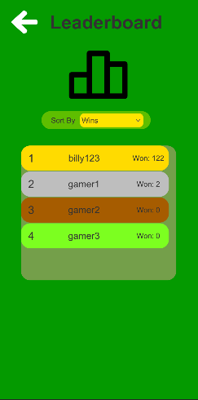

**Test 2**

1. Start VirtuCardClient application
2. Click the button labeled “Sign In”
3. Enter “micro@soft.com” into the text input labeled “Enter email…”
4. Enter “Password!123” into the text input labeled “Enter password…”
5. Press the button labeled “Login”
6. A window should appear saying “Login Success”
7. Press the button labeled “Next”
8. Press the button in the bottom right with the podium image.
9. Click the dropdown in the center of the leaderboard page labeled “Sort By”
10. Select the option labeled “Losses”

**Expected Result:** The user with the highest number of losses should be at the top while the user with lowest number of losses should be at the bottom

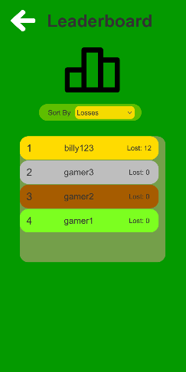

**Test 3**

1. Start VirtuCardClient application
2. Click the button labeled “Sign In”
3. Enter “micro@soft.com” into the text input labeled “Enter email…”
4. Enter “Password!123” into the text input labeled “Enter password…”
5. Press the button labeled “Login”
6. A window should appear saying “Login Success”
7. Press the button labeled “Next”
8. Press the button in the bottom right with the podium image.
9. Click the dropdown in the center of the leaderboard page labeled “Sort By”
10. Select the option labeled “Wins”
11. Click on the player in the list named “billy123”

**Expected Result:** A panel should appear at the bottom stating the name of the player clicked and their statistics.

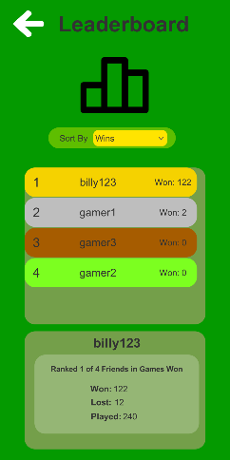

**Test 4**

1. Start VirtuCardClient application
2. Click the button labeled “Play Anonymously”

**Expected Result:** The button in the bottom right with a podium image should not be visible

